Assignment 1

I had some trouble with the power of numbers and fractions so I am using ** for power and just division (/) to show fractions.

Part 1

1. The Cartesian product of n-sets is an ordered n-tuple where the elements of each set are combined with the rest of the elements of each set and in each n-tuple there is one element from each set. For example, if we had only two sets:

A = {1,2,3} and B = {1,2,3} The cartesian product would be AXB= {(1,1),(1,2),(1,3),(2,1),(2,2),(2,3),(3,1),(3,2),(3,3)}

2.

A = {a, b, d, m, n, z, o} , B = {x, z, i, a, t} , C = {n, i, e, t, q, z, d} , compute ( ( A ∪ B ) ∩ C ) ∪ ( C ∩ B )

A ∪ B = {a,b,d,m,n,z,o,x,i,t}

( A ∪ B ) ∩ C ) = {d,n,z,i,t}

C ∩ B = {z,i,t,}

( ( A ∪ B ) ∩ C ) ∪ ( C ∩ B ) = {d,n,z,i,t}

Part 2

1 . A sample space is all the possible outcomes of an experiment and events are subsets of the sample space so a number of different outcomes. A single outcome can be considered a singleton event.

2.

i.16! = 20,922,789,888,000 (16x15x14x13x12x11x10x9x8x7x6x5x4x3x2x1)

9! = 362,880 (9x8x7x6x5x4x3x2x1)

20,922,789,888,000 x 362,880 = 7,592,461,994,557,440,000

ii. $\left({8 \atop 3}\right)$

8!/3! (8 chooses 3) = 6,720 (8x7x6x5x4x3x2x1) / (3x2x1)= 6,720

3.

i. n = 100 r = 6

Combination :(r+n-1)! / r! (n-1)!

(6 + 100-1)! / 6! (100-1)! = 1,609,344,100

Permutation: n**r

100**6 = 1,000,000,000,000

ii. Combination: n! / r! (n-r)!

100! / 6! (100-6)! = 1,192,052,400

Permutation : n! / (n-r)!

100! / (100-6)! =

100! / 94! = 858,277,728,000

4.

i. The sample space is S = {(positive,negative),(positive,positive), (negative,negative),(negative,positive)}

ii.

Pr(Antigen=Positive, PCR = Positive) = 168/437 = 0.3844

Pr(Antigen=Negative,PCR = positive) = 5/437 = 0.0114

Pr(PCR=negative, Antigen = negative) = 262/437 = 0.5995

Pr(PCR= negative, Antigen = positive) = 2/437 = 0.0046

iii.

a. Pr(Antigen = positive ∧ PCR = positive) + Pr(Antigen= negative ∧ PCR = negative) /Pr( Total = total)

168 + 262 = 430

430/437 = 0.984

b.

Pr(Antigen= positive|PCR= negative) = Pr(Antigen = positive ∧ PCR = negative)/Pr(Total = total)

2/437 = 0.0046

c. Pr (PCR = positive|Antigen=Positive)∧ Pr(PCR = positive|Antigen=Negative) = Pr(Antigen = positive ∧ PCR = positive) ∧ Pr(Antigen = negative ∧ PCR = positive)/Pr(Total = total)= 173/ 437 = 0.3959

d. Pr(Antigen = positive ∨ PCR = positive) = Pr(Antigen = positive) + Pr(PCR = positive) − Pr(Antigen = positive ∧ PCR = positive)/ Pr(Total = total)

170/437 + 173/437 - 168 /437 = 0.4005

5. Pr(Glove = identical) = 1/19 = 0.0526 That is, because when we pick two gloves out of the 20, since there are 10 pair of gloves there are still 19 possibly matching gloves to that one from the 20.

6.

I wish to wish the wish you wish to wish,

but if you wish the wish the witch wishes,

I won't wish the wish you wish to wish

|  |  |  |  |  |  |  |  |  |  |  |  |
| --- | --- | --- | --- | --- | --- | --- | --- | --- | --- | --- | --- |
|  | I | wish | to | the | you | but | if | witch | wishes | won't |  |
| I | 0 | 1 | 0 | 0 | 0 | 0 | 0 | 0 | 0 | 1 | 2 |
| wish | 0 | 0 | 3 | 4 | 2 | 1 | 0 | 0 | 0 | 0 | 10 |
| to | 0 | 3 | 0 | 0 | 0 | 0 | 0 | 0 | 0 | 0 | 3 |
| the | 0 | 3 | 0 | 0 | 0 | 0 | 0 | 1 | 0 | 0 | 4 |
| you | 0 | 3 | 0 | 0 | 0 | 0 | 0 | 0 | 0 | 0 | 3 |
| but | 0 | 0 | 0 | 0 | 0 | 0 | 1 | 0 | 0 | 0 | 1 |
| if | 0 | 0 | 0 | 0 | 1 | 0 | 0 | 0 | 0 | 0 | 1 |
| witch | 0 | 0 | 0 | 0 | 0 | 0 | 0 | 0 | 1 | 0 | 1 |
| wishes | 1 | 0 | 0 | 0 | 0 | 0 | 0 | 0 | 0 | 0 | 1 |
| won't | 0 | 1 | 0 | 0 | 0 | 0 | 0 | 0 | 0 | 0 | 1 |

|  |  |  |  |  |  |  |  |  |  |  |  |
| --- | --- | --- | --- | --- | --- | --- | --- | --- | --- | --- | --- |
|  | I | wish | to | the | you | but | if | witch | wishes | won't |  |
| I | 0 | 1/2 = 0.5 | 0 | 0 | 0 | 0 | 0 | 0 | 0 | 1/2 = 0.5 | 2 |
| wish | 0 | 0 | 3/10 = 0.3 | 4/10 = 0.4 | 2/10=0.2 | 1/10=0.1 | 0 | 0 | 0 | 0 | 10 |
| to | 0 | 3/3 = 1 | 0 | 0 | 0 | 0 | 0 | 0 | 0 | 0 | 3 |
| the | 0 | 3 /4 = 0.75 | 0 | 0 | 0 | 0 | 0 | 1/4 = 0.25 | 0 | 0 | 4 |
| you | 0 | 3/3 = 1 | 0 | 0 | 0 | 0 | 0 | 0 | 0 | 0 | 3 |
| but | 0 | 0 | 0 | 0 | 0 | 0 | 1/1 = 1 | 0 | 0 | 0 | 1 |
| if | 0 | 0 | 0 | 0 | 1/1 = 1 | 0 | 0 | 0 | 0 | 0 | 1 |
| witch | 0 | 0 | 0 | 0 | 0 | 0 | 0 | 0 | 1/1=1 | 0 | 1 |
| wishes | 1/1=1 | 0 | 0 | 0 | 0 | 0 | 0 | 0 | 0 | 0 | 1 |
| won't | 0 | 1/1=1 | 0 | 0 | 0 | 0 | 0 | 0 | 0 | 0 | 1 |

Part 3

1.

A constant is a value that doesn't change. All numbers are constants for example 6 is a constant as well 1,006 is a constant.

A variable is a symbol for a value that can change in an equation or in an experiment. For example, x = 4 is a variable but when we compute x**2 x becomes 16.

2.

i. a**2 × b**2 = 2(ab)**2

a = 2 , b = 3

2**2 x 3**2 = 2(2x3)**2

4 x 9 = 2 (6)**2

36 = 2 x 36

36 = 72 which isn't true

But it accidentally works with 0 as 0 multiplied or in the power of anything is always 0.

ii. a**2 × b**3 = (ab)**5

a = 2 , b = 3

2**2 x 3**3 = (2x3)**5

4 x 27 = 6**5

108 = 7,776 which isn't true

But it accidentally works with 0 as 0 multiplied or in the power of anything is always 0.

iii. f(x₁ + x₂) = f(x₁) + f(x₂)

f = x+1 , x1=2 , x2 =3

f(2+3) = f(5) = 5+1 = 6

f(2) + f(3) = (2+1) + (3+1) = 3+4 = 7

So in this case it doesn't hold.

But it accidentally holds when x1 and x2 is 0 because 0 adding 0 is 0.

iv. a**3 × b**3 ≠ (ab)**3

a=2, b=3

2**3 x 3**3  ≠ (2x3)**3

8 x 27 ≠ 6**3

216 ≠ 216 which isn't true

3.

i. a**4 × b**4 =  (ab)**4

a=2,b=3

a**4 × b**4  =

16 x 81 = 1,296

(ab)**4 =

(2x3)**4 =

6**4 = 1,296

ii. (a**4)**2 = a**8

a=2

(a**4)**2=

(2**4)**2=

16**2 = 256

a**8 =

2**8 = 256

4.

i. f(x)=(x**2 +2)/x

y= f(x)

y=f(10) = (10**2+2)/10 = (100+2)/10 = 102/10 = 10.2

y=f(9) = (9**2+2)/9 = (81+2)/9 = 83/9 = 9.2222

y=f(8) = (8**2+2)/8 = (64+2)/8 = 66/8 = 8.25

y=f(7) = (7**2+2)/7 = (49+2)/7 = 51/7 = 7.2857

y=f(6) = (6**2 +2)/6 = (36+2)/6 = 38/6 = 6.3333

y=f(5) = (5**2 +2)/5 = (25+2)/5 = 27/5 = 5.4

y=f(4) = (4**2+2)/4 = (16+2)/4 = 18/4 = 4.5

y=f(3) = (3**2+2)/3 = (9+2)/3 = 11/3 = 3.6667

y=f(2) = (2**2+2)/2 = (4+2)/2 = 6/2 = 3

y=f(1) = (1**2+2)/1 = (1+2)/1 = 3/1 = 3

y=f(0) = infinity (syntax error)

y=f(-1) =(-1**2+2)/-1= 1+2/-1 = 3/-1 = -3

y=f(-2) = (-2**2+2)/-2 = (4+2)/-2 = 6/-2 = -3

y=f(-3) = (-3**2+2)/-3 = (9+2)/-3 = 11/-3 = -3.6667

y=f(-4) = (-4**2+2) / -4 = (16+2)/-4 = 18/-4 = -4.5

y=f(-5) = (-5**2 +2) / -5 = (25+2)/-5 = -5.4

y=f(-6) = (-6**2+2)/-6 = (36+2) / -6 = 38/-6 = -6.3333

y=f(-7) = (-7**2+2)/-7 = (49+2)/-7 = 51/-7 = -7.2857

y=f(-8) = (-8**2+2)/-8 = (64+2)/-8 = 66/-8 = -8.25

y=f(-9) = (-9**2+2)/-9 = (81+2)/-9 = 83/-9 = -9.2222

y=f(-10)= (-10**2+2)/-10 = (100+2)/-100 = 102/-100 = -10.2

ii. Δy/Δx = (4.5-3)/(4-2) = 0.75

Δy/Δx =( 3.667-3)/ (3-2) = 0.667/1 = 0.667

y=f(2.5) = (2.5**2+2)/2.5 = 6.25+2/2.5 = 8.25/2.5 = 3.3

Δy/Δx = (3.3-3)/(2.5-2) = 0.6

y=f(2.25) = (2.25**2+2)/2.25 = (5.0625+2)/2.25 = 7.0625/2.25 = 3.1389

Δy/Δx = (3.1389-3) /(2.25-2) = 0.5556

y=f(2.125) = (2.125**2+2)/2.125 = (4.515625+2)/2.125 = 6.515625/2.125 = 3.066176

Δy/Δx = (3.066176-3)/(2.125-2) = 0.066176/0.125 = 0.529408

Graph with secant lines:

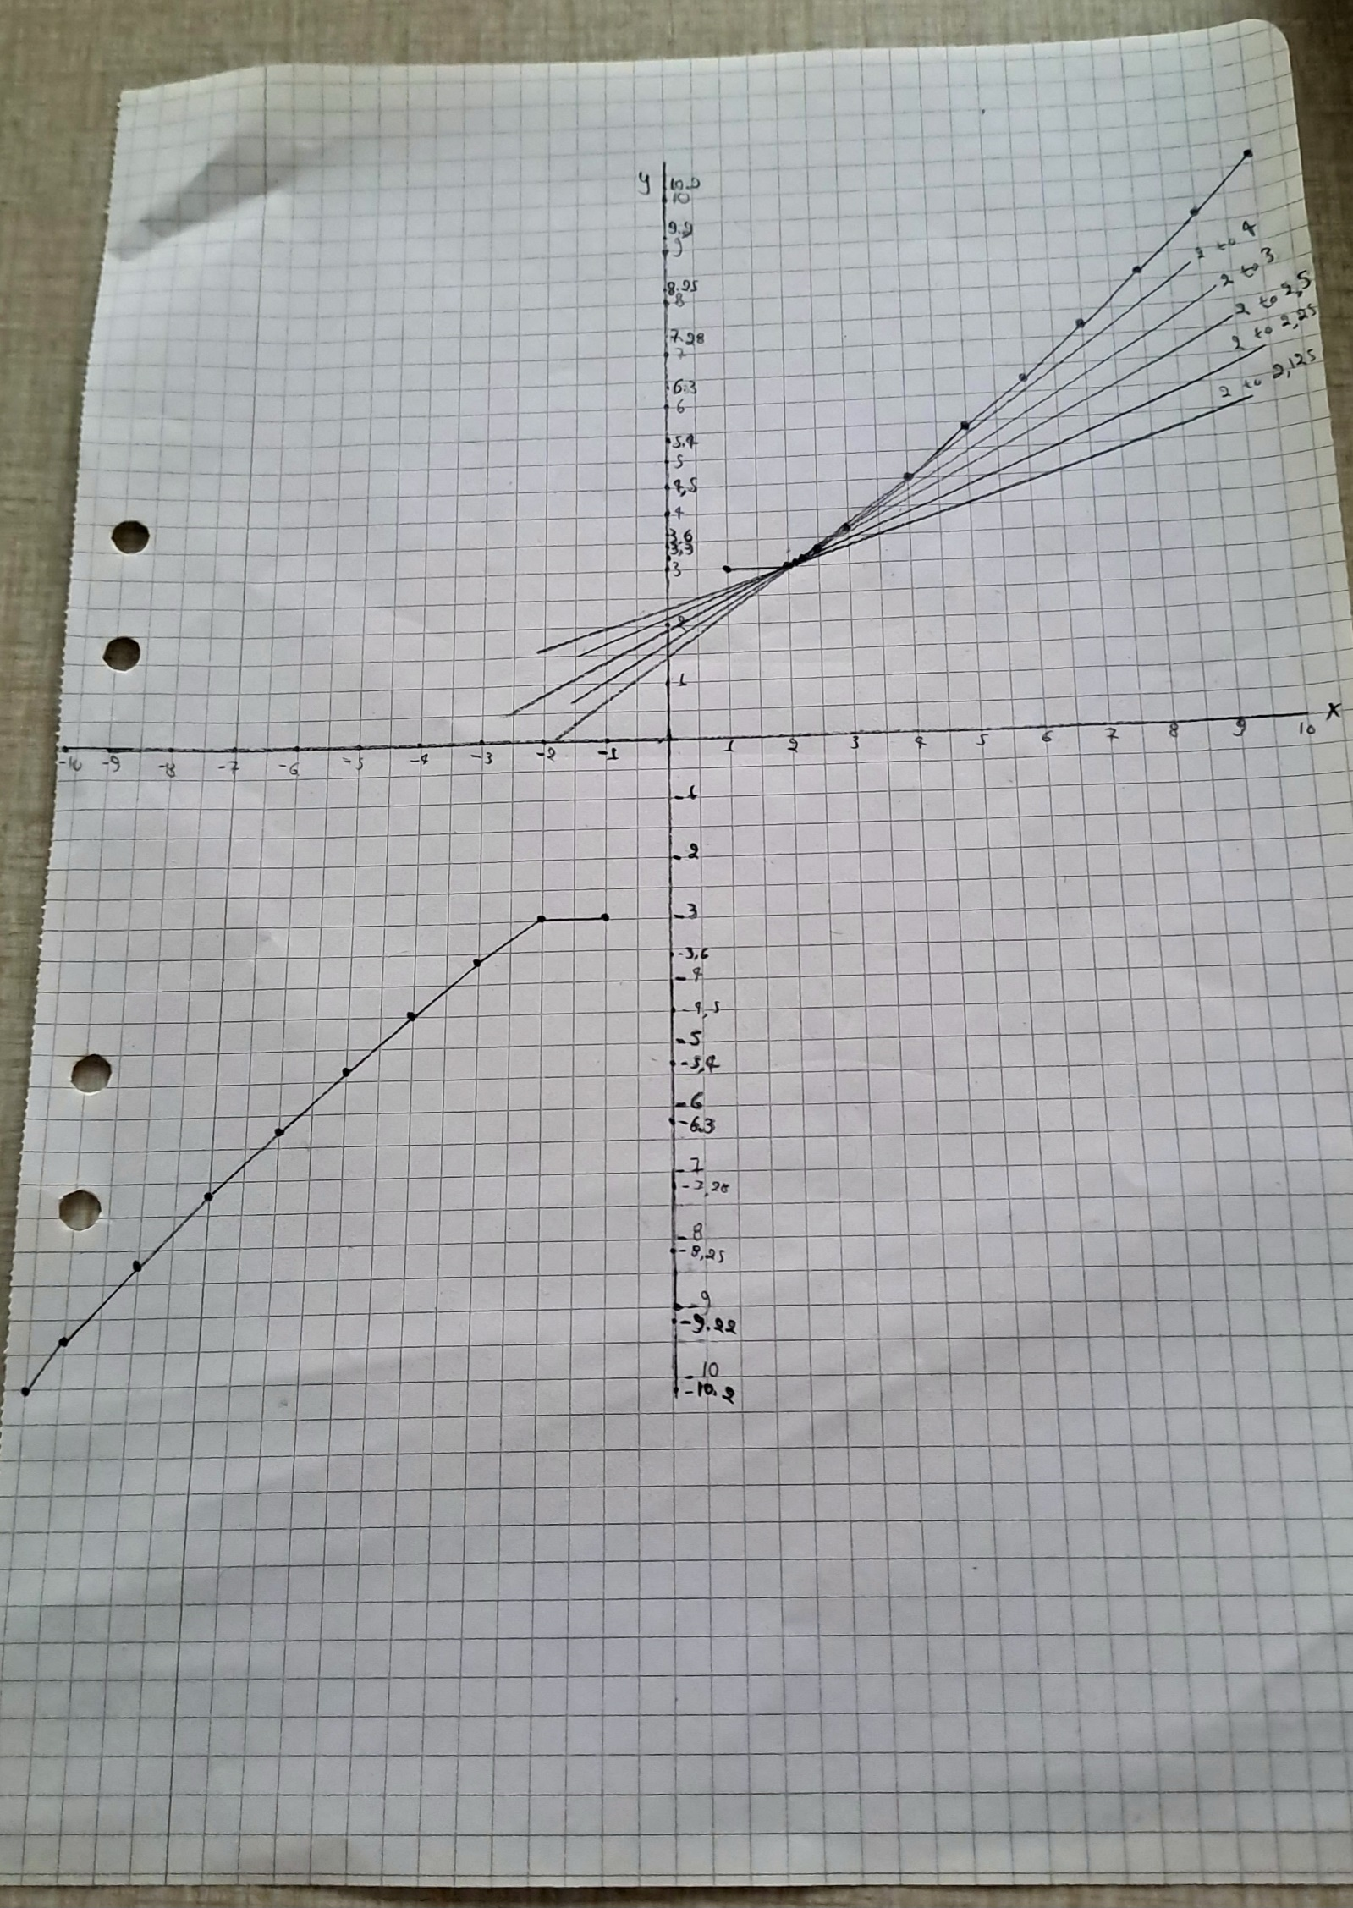

Part 4

1. a= (3,7,10,2)

b=(16,5,8,3)

=

2. A3x2=

B2x3 = $\left[\begin{matrix}1 & 4 -2 \\ 2 & 0 1\end{matrix}\right]$

$$AB=C 3x3\left[\begin{matrix}2x1+0x2 & 2x4+0x0 & 2x-2+0x1 \\ -1x1+4x2 & -1x4+4x0 & -1x-2+4x1 \\ 5x1+1x2 & 5x4+1x0 & 5x-2+1x1\end{matrix}\right]= \left[\begin{matrix}2 & 8 & -4 \\ 7 & -4 & 6 \\ 7 & 20 & -9\end{matrix}\right]$$

BA = C 2X2 $\left[\begin{matrix}1x2+4x-1+-2x5 & 1x0+4x4+-2x1 \\ 2x2+0x-1+1x5 & 2x0+0x4+1x1\end{matrix}\right]= \left[\begin{matrix}-12 & 14 \\ 9 & 1\end{matrix}\right]$

3.

$$A3x4=\left[\begin{matrix}0 & 1 & 2 & 1 \\ 2 & 0 & -1 & 4 \\ 0 & -2 & 1 & 3\end{matrix}\right]$$

A**T = A4x3 =

Bonus Points

1. Multivariate calculus is concerned with calculating multiple variables instead of just one for example with functions like f(x,y) = x**2 - 2y**2. It is useful when we are looking for information in multiple dimensions.

2. Joint probability is the probability of two events occurring at the same time. Conditional probability is the probability of an event occurring in the presence of another event and how that changes it. These are calculated differently.

3. According to the quotient rule:

f(x)/g(x) = f'(x)g(x)-f(x)g'(x) / (g(x))**2

f(x) = x**2+2

f'(x) = 2x**(2-1) = 2x

g(x) = x

g'(x) = 1x**(1-1)=1x**0 = 1

So:

f'(x) = (2x * x - (x**2+2)*1) / x**2 =

2x**- x**2 -2/x**2= x**2-2/x**2

So x=2:

f'(x) = 2**2-2/2**2 = 4-2/4 = 2/4 = 0.5